**METHODS**

**Honey bee source**:

For all experiments, honey bee subjects were derived from colonies managed at the Iowa State University Horticulture Research Station. All were produced from open-mated queens from commercial stocks.

**Experiment 1: Acute larval starvation**

First, we sought to produce honey bee adults that experienced a highly standardized form of nutritional deprivation as larvae but were still reared under mostly normal colony conditions. To do so, we used a protocol identical to that described in Walton et al 2018, as modified from Wang et al 2014, 2016a, 2016b. In July 2014, five queens from five separate honey bee colonies were caged over a frame of drawn, empty comb, for 48h. After this interval, the cages were removed and frames placed back into the colony; eggs were then allowed to hatch and larvae mature as normal. At 180h after the egg laying interval, the acute starvation treatment, or a control treatment, was performed on each frame. Frames were removed from the colony and nurse bees brushed off the frame completely. A wire push-in cage was then placed over half of the developing larvae, preventing nurse bees from accessing them for feeding; the other half of the larvae on the frame remained accessible. Each frame was outside of the colony <2 minutes during the treatment. The frame was returned to the colony for 10 h, with bees maturing to approximately at the developmental stage where larvae initiate spinning and stop feeding (Jay 1963). After this point, the frames were taken from the frames briefly and the push in cages removed, again allowing access by adult workers. Because honey bee larval development is highly regimented, focusing our starvation period to end at the spinning phase does not allow a window for compensatory feeding by the workers; i.e., they cannot feed the starved workers more after the treatment. After the starvation treatment, frames were returned to the colony and the pupae allowed to mature normally to the pharate stage, after which they were removed from the colony and placed in an incubator at 33C overnight. Separate enclosures were placed over each treatment (starved vs control) on each frame to keep emerging adults separate. Once adults had emerged, the treatment and control bees were separated and the resulting bees mixed between the five colony sources. Within the first 24h after emergence, they were then separated into observation cages and treated as described below. This procedure was repeated twice, thus producing two separate generations of workers that experienced these conditions.

**Experiment 2: Pollen quality limitation**

While Experiment 1 allows a repeatable, standardized nutritional treatment, it is also confounded by the restriction of nurse bees performing other behaviors with the developing larvae, such as grooming and cleaning. Further, such a short, but dramatic, separation from nurse bee care may be unlikely under natural conditions. However, honey bee nutrition can also be affected by the quantity or quality of the food they have access to; recent years have seen an increasing focus on understanding how different nutritional sources affect bees’ resilience to other stressors (Wright 2019). Therefore, we performed a second set of experiments where we sought to produce adult bees that experienced chronic differences in nutrition during the entirety of development. This poses a challenge as honey bees will not rear larvae successfully if the colony is under full starvation conditions (REF). Instead, we produced experimental colonies that received pollen diets from single-source pollens that are both naturally collected by bees and have previously been associated with causing different responses to immune challenge (DiPasquale et al 2013; Dolezal et al 2019; Rutter et al 2019).

To accomplish this, in July 2015, we produced four experimental colonies as the mechanism for delivering the nutritional treatment to our focal larvae. Two colonies would receive putatively high quality *Castanea spp.* pollen and the other two putatively lower quality *Cistus* *sp.* pollen. Each of these colonies was housed in a standard single deep box per standard beekeeping protocols. Each hive contained ten frames, as follows: two drawn (i.e., covered in wax comb) but empty frames; two drawn frames with one side filled with honey; one frame with capped brood (pupae); 5 frames of foundation (to be removed later). Great care was taken to only use frames that contained no stored pollen.

The colonies were started in these hives by brushing frames of nurse bees from four brood-containing frames from six different colonies (i.e., 24 frames of bees) into a single container. These were them mixed gently to create a large homogenate of worker bees. From this mixture, approximately 4000 workers were measured out by volume (1.3 liters) and added to one of the four experimental hives. As such, each hive began the experiment with an identical worker population from a single homogenated worker source. Each colony also received a standardized queen signal, in the form of a commercially available pseudoqueen; use of this standardized signal removes variation in behavior that may occur due to different queen quality stimuli sensed by the workers.

To differentiate the hives by nutritional treatment, each colony was fitted with a ‘front porch’ style pollen trap (DeGrandi-Hoffman et al 2016 <https://doi.org/10.1007/s13592-015-0386-6>) that was constantly engaged. This device knocks the majority of the pollen off of the legs of returning foragers, effectively precluding the colony from accessing pollen resources from the landscape while allowing for free flight of workers and collection of nectar. Instead, each colony received an experimental pollen treatment, placed on the top bars of each colony, made up of moistened *Castanea* or *Cistus* pollen formed into a 0.5 kg patty. This patty would be replaced every three days or supplemented if observed being depleted more quickly. Thus, each colony was provided *ad libitum* access to their respective pollen treatment, but was not able to gather pollen resources from natural forage.

Because the nutritional status of the workers decides the quality of food delivered to the larvae, it was necessary to first maintain these colonies under experimental conditions for multiple generations of workers to ensure the nutritional treatment was established. The first generation of workers were those in the original colony production, made up of a mixture of workers from wild type colonies; these would first start to be succeeded by the bees emerging from the capped brood frame present in the colony at the beginning. These bees, while experiencing normal larval development, emerged as adults into the nutritional treatment. A second and third frame of pupae was added to each colony once per week for the next three weeks. Also added to each colony were frames of eggs derived from one of four different queens in the general apiary; these provided larvae for the workers to care for to simulate a normal colony environment in the lead up to the production of the focal bees. When placed into each experimental hive, a frame of undrawn foundation was removed to make space. At 21 days after the creation of the colony (the duration of a worker bees’ development from egg to adulthood), a two frames, each partially filled with newly-laid eggs from different unmanipulated queens, was added to each colony. These eggs were allowed to develop normally within the colony until the they had reached the pharate stage, after which they were removed to a 33C incubator for adult emergence. Once adults had emerged, they were mixed by treatment (i.e., all of the bees derived from *Cistus-*treated hives were combined and homogenized) and separated into observation cages for treatment as described below. This procedure was repeated twice more, once 14 days after the original addition of focal eggs, and once more 14 days after that. Each iteration used eggs derived from different, randomly-selected queens. Thus, we produced three separate generations of adults that experienced the hive nutritional treatment. Throughout this period, approximately 500 newly-emerged adults was added to each colony per week to ensure continuation of a stable population that experienced the hive nutritional treatment for their entire adulthood.

**Body analysis of nutritional treatments**

For each nutritional treatment, body mass and total lipid content was measured on a subset of newly-emerged bees (pre-virus treatment) that were not used in the cage assays. For experiment 1, 16 bees from the starvation treatment and 20 from the normal diet treatment were weighed; 6 from each treatment were assayed for lipid content. For experiment 2, 12 *Cistus-*reared and 10 *Castanea-*reared bees were weighed and measured for lipid content. Lipid content was assayed as described in Toth and Robinson 2005, as modified by Dolezal et al 2016.

**Cage assays**

For both experiments, newly-emerged bees were formed into cages and assayed for survival against a challenge with a virus inoculum previously shown to cause repeatable mortality due to infection primarily with Israeli acute paralysis virus (IAPV) using methods identical to those described in Dolezal et al 2019, as modified from Carrillo-Tripp et al 2016. In short, 30 newly emerged bees derived from the treatment-specific mixture of bees were placed into an acrylic observation cage ( dimensions: 10.6 × 10.16 × 7.62 cm). Within 2h of the formation of each cage, a small weigh boat containing 600 µl of 30% sucrose solution was placed on the floor of each cage. Control cages received only sterile sucrose solution; virus treatment cages received a 1:1000 dilution of a virus inoculum, identical to that described in Carrillo-Tripp et al 2016 and Dolezal et al 2019. After 16 h, the solution in each cage had been completely consumed by the workers; then, a top feeder of sterile 30% sucrose solution was added to the top of each cage, providing virus-free diet *ad libitum* for the remainder of the experiment. Mortality in each cage was monitored each day for four (96h) days, the duration previously shown to be necessary to observe virus-induced mortality. At 36 hpi, 3 live bees were sampled from each cage for virus titer and gene expression analysis.

Thus, for Experiment 1, there were four cage treatments: starvation+sucrose control; starvation+virus; normal diet+sucrose control; starvation+virus. The first generation of workers reared under treatment conditions were used to produce 39 cages (n=9 for starvation+virus; n=10 for all others); the second generation produced 40 more cage (n=10 per treatment), for a final of 79 total cages (n=19 for starvation+virus; n=20 for all others). For experiment two, there were also four cage treatments, spread across three generations: *Cistus-reared*+sucrose control; *Cistus*-*reared*+virus; *Castanea-reared*+sucrose control; *Castanea-reared* +virus. Because there were more variable numbers of bees reared in the more natural but less controlled conditions, the number of cages produced from each generation was more variable, as follows. *Cistus-*reared+sucrose control (generation 1, n=8; generation 2, n=5; generation 3, n=8; total n=21); *Cistus*-reared+virus (generation 1, n=9; generation 2, n=6; generation 3, n=7; total n=22 ); *Castanea*-reared+sucrose control (generation 1, n=3; generation 2, n=6; generation 3, n=2; total n=11); *Castanea-*reared+virus (generation 1, n=3; generation 2, n=6; generation 3, n=2; total n=11).

**Virus titration**

From the 6 bees collected from each cage at 36 hours post treatment, RNA was extracted and IAPV titer measured on the pooled RNA of bees from 10 randomly-selected subset of cages from each treatment; this was done identically to the methods of Dolezal et al 2019 and Geffre et al 2020. In short, RNA was extracted from each sample using Trizol reagent; this material was then cleaned and treated with DNAse. RNA concentration was then equalized across all samples and measured via qPCR against an RNA standard curve used estimate viral genome equivalents.

**Gene expression**

Alex add.

**Statistical analysis**

For all experiments, analyses were performed in R using version 3.3.1 (ref). For experiments 1 and 2, survival against the virus challenge was analyzed by comparing the proportion of each cage that survived the bioassay between the treatments via a linear mixed effects model using the lmer function from the package lme4 (ref), with treatment generation as a random factor. ANOVAs followed by a Tukey HSD posthoc test, using the package multcomp, were performed on these models. Mass and lipid contents were compared using Welch’s t-test. Virus titers were log transformed to meet assumptions of normality and then compared across treatments using the same mixed model approach as described for survival.

Gene expression ---- Alex add

**RESULTS**

**Experiment 1** : Acute larval starvation

**Body quality analysis:** Bees derived reared under the acute starvation conditions weighed significantly less than those reared under normal diet conditions (Welch’s t-test, t=3.53, d.f.=33.13, p=0.0012; nstarvation=16; nnormal=20), but the proportion of their mass made up of lipids did not differ (Welch’s t-test, t=-2.16, d.f.=7.27, p=0.067; nstarvation=6; nnormal=6). Supplementary figure?

**Virus challenge bioassay**: Across the four nutrition/virus treatments, there were significant differences in the proportion of bees that died during the 96h assay (Figure 1a; mixed model ANOVA across all treatment groups, d.f. = 3, 6; *F=* 40.45*;* p <0.0001; nstarvation+virus=19; n=20 for all others), with all treatment groups significantly different from each other (Tukey HSD, p< 0.001) except the starvation+sucrose and normal diet+sucrose groups (Tukey HSD, p=0.28).

**IAPV titers:** Across the four nutrition/virus treatments, there were significant differences in the IAPV titers of bees collected 36h into the assay (Figure 1b; mixed model ANOVA across all treatment groups, *F=* 13.6; p <0.0001; n=10 per treatment), with all treatment groups significantly different from each other (Tukey HSD, p< 0.001) except the starvation+sucrose and normal diet+sucrose groups (Tukey HSD, p=0.52) and the starvation+virus and normal diet+virus (Tukey HSD, p=0.79).

**Gene expression: Figure 2?**

**Experiment 2**: Pollen quality limitation

**Body quality analysis:** There were no significant differences in the mass or lipid content of bees from the *Castanea* and *Cistus* treatments (Welch’s t-test, p>0.05;: n*Cistus*=12, n*Castanea*=10; ).********I can’t find these numbers right now but could add ‘em

**Virus challenge bioassay**: Across the four nutrition/virus treatments, there were significant differences in the proportion of bees that died during the 96h assay (Figure 3a; mixed model ANOVA across all treatment groups, d.f. = 3, 6; *F=* 4.7; p <0.005; n*Cistus+*sucrose=21, n*Cistus+*virus=22, n*Castanea+*sucrose =11, n*Castanea+*virus =11. Comparing between the treatments, the *Cistus*-reared+virus vs. *Cistus*-reared+sucrose (Tukey HSD, p< 0.004) and *Cistus*-reared+virus vs. *Castanea-*reared+control (Tukey HSD, p=0.024) were significantly different, but no other groups were (Tukey HSD, p>0.05).

**IAPV titers:** Across the four nutrition/virus treatments, there were significant differences in the IAPV titers of bees collected 36h into the assay (Figure 3b, mixed model ANOVA across all treatment groups, d.f. = 3, 6; *F=* 6.46; p <0.0026; n*Cistus+*sucrose=5, n*Cistus+*virus=12, n*Castanea+*sucrose =2, n*Castanea+*virus =5). Comparing between the treatments, the *Cistus*-reared+virus vs. *Cistus*-reared+sucrose (Tukey HSD, p< 0.001) and *Cistus*-reared+virus vs. *Castanea-*reared+control (Tukey HSD, p=0.0148) were significantly different, but no other groups were (Tukey HSD, p>0.05).

**Gene expression: Figure 4?**

**Figures:**

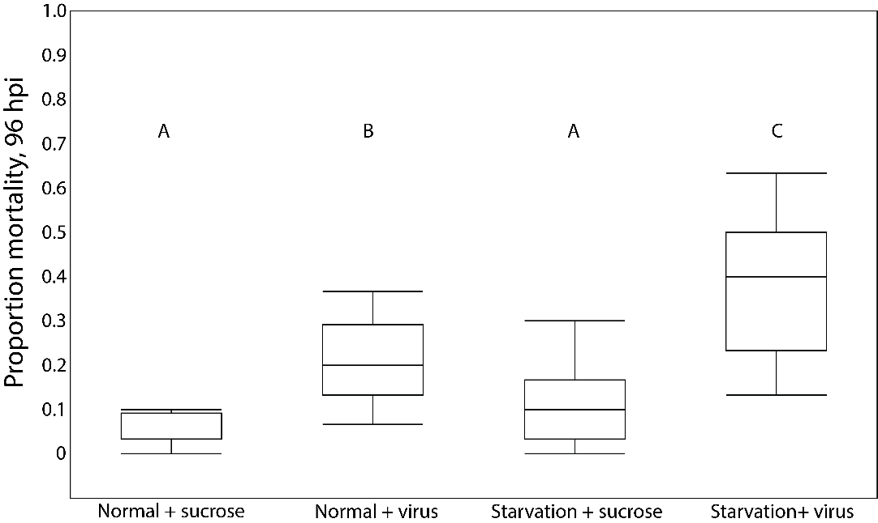

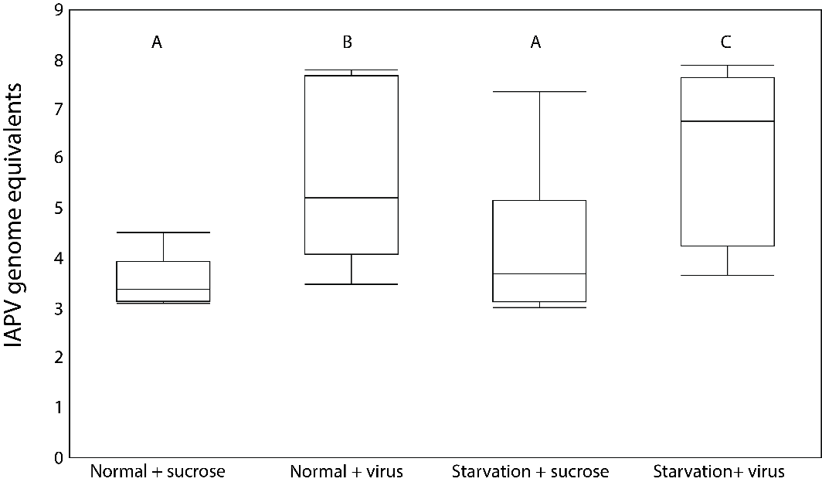

**Figure 1** A) Proportion mortality in cages of bees that experienced normal or starvation conditions during development fed sterile sucrose or virus inoculum as adults, 96 hours post inoculation (hpi); B) Estimated genome equivalents, calculated against a standard curve, of IAPV in pooled samples from randomly-selected cages from each treatment. Boxplots display median, interquartile range, and full data range. Letters denote significant differences (ANOVA followed by Tukey HSD, p<0.05).

Figure 2: Gene expression data from acute cages

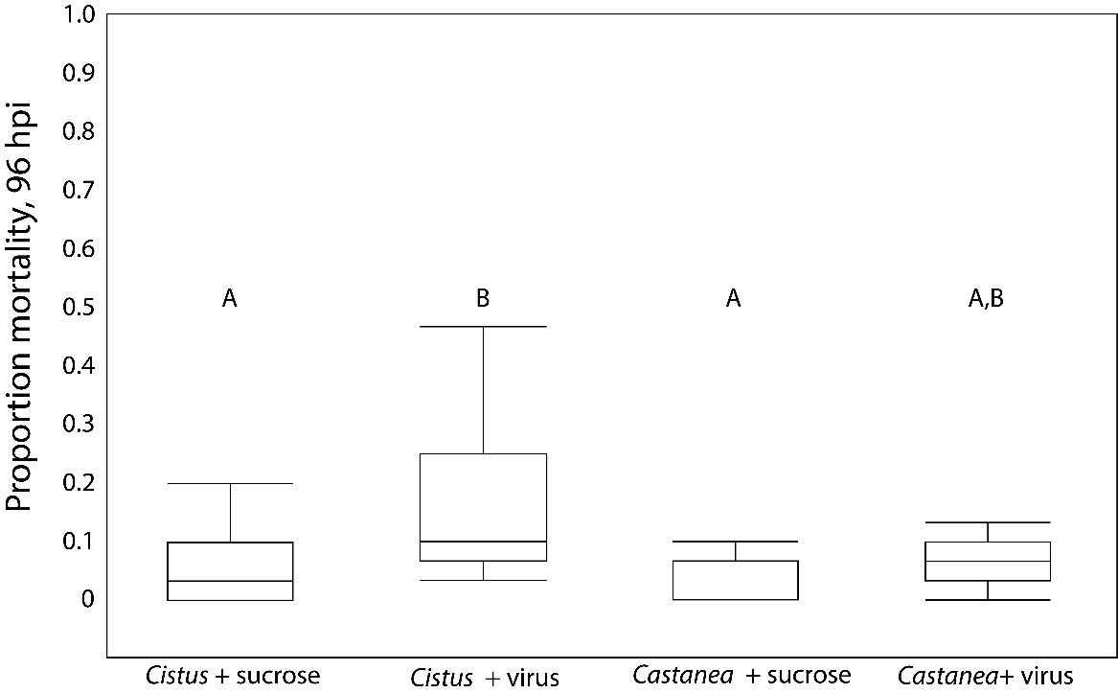

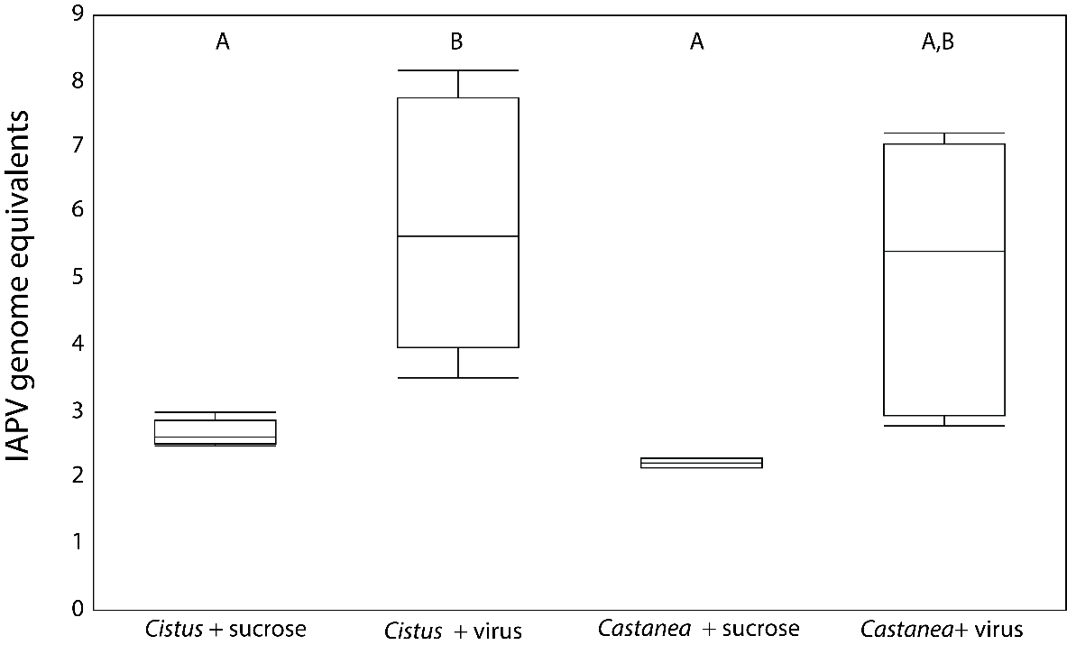

**Figure 3** A) Proportion mortality in cages of bees reared under *Cistus* or *Castanea*-only hive conditions fed sterile sucrose or virus inoculum as adults, 96 hours post inoculation (hpi); B) Estimated genome equivalents, calculated against a standard curve, of IAPV in pooled samples from randomly-selected cages from each treatment. Boxplots display median, interquartile range, and full data range. Letters denote significant differences (ANOVA followed by Tukey HSD, p<0.05).

**Figure 4: Chronic gene expression**

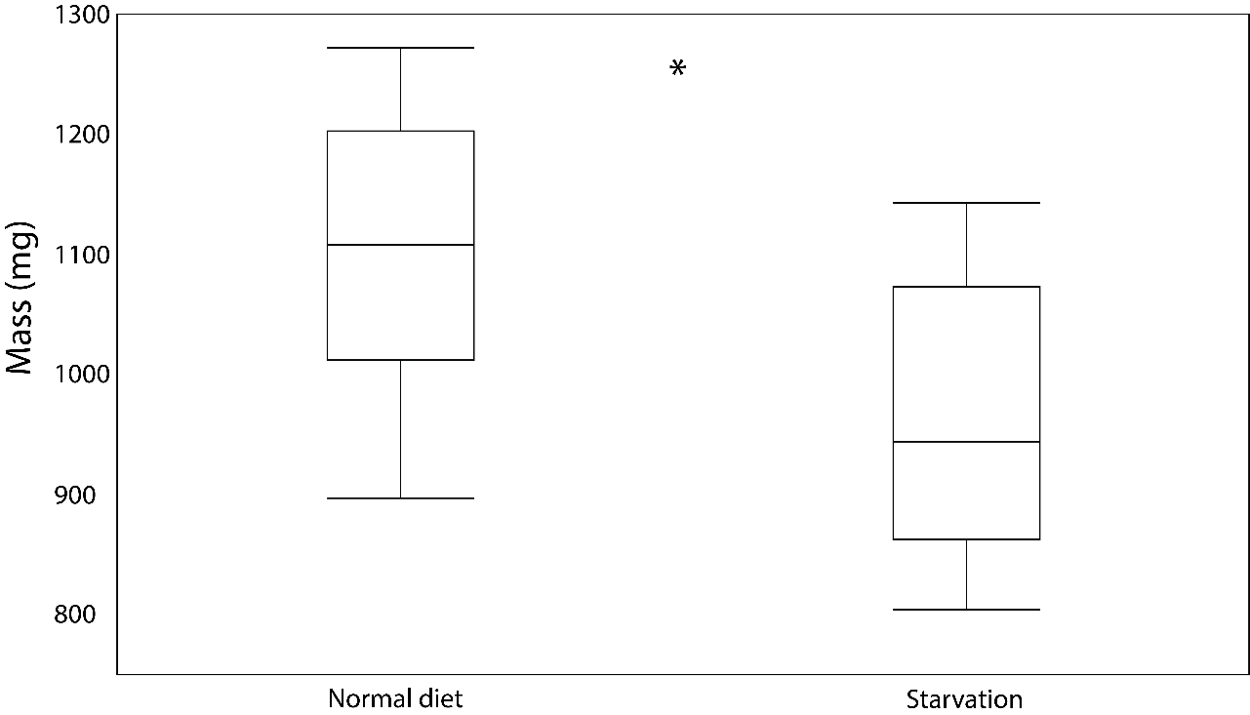

**Supplemental figure?:** Mass (mg) of bees reared under normal and starvation conditions. Boxplots display median, interquartile range, and full data range. Asterisk denotes significant difference (Welch’s t-test, p<0.05).

**probably should make this for Chronic even though its not significantly different